MANUKHTA DI SEWA (A web application for Manukhta di Sewa society)

# MAJOR PROJECT REPORT

SUBMITTED IN PARTIAL FULFILMENT OF THE REQUIREMENTS FOR THE AWARD OF THE DEGREE OF

**BACHELOR OF TECHNOLOGY**

(Computer Science And Engineering)



Submitted By:- Submitted To.:

Anjali Singh (2004537) Prof. Goldendeep Kaur

Harbaksh Kaur (2004579)

**DEPARTMENT OF COMPUTER SCIENCE AND ENGINEERING**

**GURU NANAK DEV ENGINEERING COLLEGE**

**LUDHIANA, 141006 April, 2024**

**Abstract**

SEWA is a comprehensive web application designed to streamline community engagement and volunteer management processes. In an era where civic participation and community involvement are essential for societal progress, SEWA provides a user-friendly platform that connects volunteers with organizations, facilitates seamless communication, and enhances overall efficiency in managing volunteer activities.

The primary objective of SEWA is to bridge the gap between volunteers and organizations by offering a centralized platform where both parties can easily interact and collaborate. Through intuitive features and a user-friendly interface, SEWA empowers organizations to recruit, coordinate, and retain volunteers effectively. Likewise, volunteers can discover meaningful opportunities, track their contributions, and stay updated on relevant events and initiatives within their communities.

One of the key features of SEWA is its robust volunteer management system, which allows organizations to create and manage volunteer opportunities with ease. Organizations can post detailed descriptions of volunteer roles, specify requirements, and set up schedules using SEWA's intuitive dashboard. Volunteers, on the other hand, can browse through available opportunities, express interest, and sign up for activities that align with their interests and skills.

SEWA facilitates seamless communication between volunteers and organizations through built-in messaging tools and notification systems. This ensures that volunteers receive timely updates, instructions, and reminders regarding their commitments, while organizations can efficiently communicate important announcements and coordinate with their volunteer base.

Furthermore, SEWA offers advanced analytics and reporting capabilities that enable organizations to gain insights into volunteer demographics, engagement levels, and impact metrics. By tracking volunteer participation and measuring the outcomes of their initiatives, organizations can make data-driven decisions, optimize their volunteer programs, and demonstrate their social impact to stakeholders.

In addition to its core functionalities, SEWA prioritizes user experience and accessibility, ensuring that the platform is inclusive and easy to navigate for users of all backgrounds and abilities. With responsive design and support for multiple languages, SEWA aims to reach a diverse audience and promote widespread participation in community-driven initiatives.

Overall, SEWA represents a significant advancement in community engagement and volunteer management technology. By harnessing the power of digital innovation, SEWA empowers organizations to maximize their impact, mobilize volunteers more effectively, and create positive change in communities around the world. Whether it's supporting local non-profits, organizing grassroots campaigns, or participating in humanitarian efforts, SEWA provides the tools and resources needed to facilitate meaningful connections and drive collective action toward a brighter future.

Top of Form

**ACKNOWLEDGEMENT**

We are highly grateful to Dr. Sehijpal Singh, Principal, Guru Nanak Dev Engineering College (GNDEC), Ludhiana, for providing this opportunity to carry out the major project work at SEWA.

The constant guidance and encouragement received from Dr. Kiran Jyoti, H.O.D. CSE Department, GNDEC Ludhiana has been of great help in carrying out the project work and is acknowledged with reverential thanks.

We would like to express a deep sense of gratitude and thanks profusely to *Prof. Goldendeep Kaur*, without his/her wise counsel and able guidance, it would have been impossible to complete the project in this manner.

We express gratitude to other faculty members of computer science and engineering department of GNDEC for their intellectual support throughout the course of this work.

Finally, we are indebted to all whosoever have contributed in this report work.

Anjali Singh

Harbaksh Kaur

**TABLE OF CONTENTS**

**Contents Page No.**

***Abstract 2***

***Acknowledgment 3***

***List of Figures 4***

***Table of Contents***

***Chapter 1: Introduction 6 to 8***

* 1. ***Introduction of the project***

***1.2. Project Category***

***1.3. Objectives of the project***

***Chapter 2: System Requirements 9 to 10***

***2.1.*  *Software Requirements***

***2.2. Hardware Requirements***

***Chapter 3: Software Requirement Analysis 11 to 16***

***3.1. Define a problem***

***3.2. Feasibility Study***

***3.3. Define the modules and their functionalities***

***3.4. SDLC model to be used***

***3.5. Recognition of need***

***Chapter 4: Software Design 17 to 24***

***4.1. Flowchart***

***4.2. Sequence Diagram***

***4.3. Data Flow Diagram***

***4.4. ER Diagram***

***4.5. Test Cases***

***4.6. Methodology***

***Chapter 5: Testing Module 25 to 26***

***Chapter 6: Performance of the project developed 27 to 38***

***Chapter 7: Future Scope 39 to 40***

## *Chapter 8: References 41*

# CHAPTER 1 – INTRODUCTION

## 1.1 Introduction of the project

In a world where compassion knows no bounds, NGO tirelessly works towards creating a better tomorrow for marginalized communities, providing them with education, healthcare, and essential resources. The SEWA donation app is designed to make your giving experience seamless, transparent, and deeply rewarding.

the gateway to making a meaningful impact in the lives of those in need. We believe in the power of collective generosity to bring about positive change, and with our user-friendly app, you can now contribute effortlessly towards our noble cause.

### Key Features

1. Effortless Giving: The app simplifies the donation process, allowing you to contribute with just a few taps. Your support can make a significant difference in the lives of those less fortunate.
2. Transparency and Accountability: We prioritize transparency in all our endeavors. The app provides real-time updates on how your donations are utilized, ensuring that you can witness the impact of your generosity first hand.
3. Customizable Giving Options: Tailor your donations to align with your passions. Whether you want to support education, healthcare, or emergency relief efforts, our app allows you to choose where your contribution goes.
4. Secure Transactions: Rest easy knowing that your financial information is secure. Our app employs state-of-the-art security measures to safeguard your transactions and personal details.
5. Stay Connected: Receive regular updates on our projects, success stories, and the impact of your contributions. Stay connected with the community you are supporting through our app's communication features.

**1.2 Project Category**

## In our web donation application categorization plays a crucial role in organizing and presenting various aspects of the donation process. Here's how you can categorize different elements of our application:

1. Donation Categories:
   * Define different categories for donations based on the causes they support. For example, categories could include education, healthcare, environment, disaster relief, etc. Each category would have its own page or section on the website where users can learn more about the cause and make donations specifically towards that cause.
2. User Categories:
   * Categorize users based on their roles or levels of engagement. This could include donors, administrators, moderators, and beneficiaries. Each user category would have different levels of access and permissions within the application. For example, donors can view donation options and submit donations, while administrators have access to manage donations, users, and content.
3. Donation Progress Categories:
   * Categorize donation progress to show the impact of donations and encourage further contributions. This could include displaying progress bars or charts indicating how much of the donation goal has been reached for each category or specific campaigns within a category. For instance, users can see that the education category has reached 70% of its goal, motivating them to contribute towards completing the goal.
4. Campaign Categories:
   * Organize fundraising campaigns within each donation category. Campaigns could be time-bound or ongoing initiatives aimed at achieving specific goals within a category. For example, within the healthcare category, there could be campaigns for building hospitals, providing medical supplies, or funding medical research. Users can choose which campaign they want to support with their donations.
5. Payment Categories:
   * Provide users with different payment options and categorize them based on their preferences and convenience. Payment categories could include credit/debit card payments, PayPal, bank transfers, cryptocurrency donations, etc. Each payment category would have its own interface for users to securely complete their transactions.
6. Content Categories:
   * Categorize content such as articles, testimonials, success stories, and updates related to each donation category. This helps users stay informed about the impact of their donations and the progress of various initiatives. For example, under the environment category, users can read articles about conservation efforts, watch videos about wildlife rehabilitation, and see photos of reforestation projects.
7. Accessibility Categories:
   * Ensure accessibility for users with different needs by categorizing features and content based on accessibility requirements. This could include providing options for text resizing, color contrast adjustments, screen reader compatibility, and keyboard navigation. Categorizing accessibility features ensures that all users, regardless of their abilities, can access and engage with the donation application effectively.

**1.3 Objectives of the project**

1. To create web application platform for NGO and donors.
2. To create a chat room for secure communication and transaction.
3. To enables the payments.

# CHAPTER 2 – SYSTEM REQUIREMENTS

**2.1 Software Requirements**

1. User registration and Management:

* Users can create accounts using their email addresses or social media accounts.
* Users can manage their profiles, including updating personal information and preferences.
* Admin panel for managing user accounts, including roles and permissions.

1. Donation Processing:

* Secure form for donors to enter donation amounts and personal information.
* Support for multiple payment methods (credit/debit cards, PayPal, bank transfers, etc.).
* Recurring donation options, allowing users to set up automatic donations on a regular basis.
* Donation history for users to view their past donations.

1. Project/Campaign Management:

* Ability for admins to create, edit, and manage donation campaigns or projects.
* Display of detailed information about campaigns, including goals, progress, and impact stories.
* Option for donors to select specific projects or campaigns to donate to.

1. Reporting and Analytics:

* Comprehensive reporting tools for administrators to track donations, campaign progress, and user engagement.
* Analytics dashboard for real-time monitoring of key performance indicators (KPIs).
* Donation receipts and thank-you emails automatically sent to donors.

1. Security:

* Secure handling and storage of personal and payment information.
* Compliance with Payment Card Industry Data Security Standard (PCI DSS) for payment processing.
* Regular security audits and updates to ensure data protection.

## 2.2 Hardware Requirements

* Processor (CPU):Quad-Core processor, 2.4 GHz or higher. This should be sufficient to handle web requests efficiently.
* Memory (RAM):At least 8GB RAM. This allows for multiple processes to run smoothly, including your web server, database, and any background tasks.
* Storage:SSD with at least 256GB of space. SSDs offer faster data access speeds, which can significantly improve site performance. Space requirements depend on your website's data storage needs.
* Network:A reliable internet connection with at least 100 Mbps bandwidth. This ensures that your website can handle multiple concurrent users without significant slowdowns.

# CHAPTER 3 – SOFTWARE REQUIREMENT ANALYSIS

## 3.1 Define a problem

## Creating a web application for donations addresses several key problems and challenges faced by both charitable organizations and potential donors. The primary problem that such an application aims to solve is the inefficiency and lack of accessibility in traditional donation processes.

## Firstly, traditional donation methods often involve manual processes, such as filling out paper forms or making donations in person or over the phone. These methods can be time-consuming and inconvenient for both donors and organizations. A web application streamlines the donation process by providing a user-friendly platform where donors can easily make contributions online, eliminating the need for manual paperwork and reducing administrative overhead for organizations.

## Secondly, traditional donation methods may lack transparency and accountability, leading to concerns among donors about how their contributions are being utilized. A web application for donations can address these concerns by providing transparency features such as real-time tracking of donations and detailed reports on how funds are allocated and used by the organization. This transparency helps build trust and confidence among donors, encouraging them to contribute more frequently and generously.

## Another significant problem that a donation web application addresses is the limited reach of traditional fundraising efforts. Traditional methods often rely on local events or face-to-face interactions to solicit donations, limiting the organization's ability to reach a wider audience. With a web application, organizations can expand their reach globally, tapping into a larger pool of potential donors and supporters. This increased reach enables organizations to raise more funds and support their causes more effectively.

## Furthermore, traditional donation methods may lack personalization and engagement, making it challenging for organizations to cultivate long-term relationships with donors. A web application can incorporate features such as personalized donor profiles, donation history tracking, and interactive communication tools to foster deeper connections between donors and organizations. By engaging donors more effectively and providing personalized experiences, organizations can enhance donor loyalty and retention over time.

## In summary, a web application for donations addresses several key problems in traditional fundraising processes, including inefficiency, lack of transparency, limited reach, and insufficient engagement. By streamlining the donation process, providing transparency and accountability, expanding reach, and enhancing donor engagement, such an application empowers organizations to raise more funds, support their causes more effectively, and build stronger relationships with donors. Ultimately, the goal of a donation web application is to make the process of giving easier, more transparent, and more rewarding for both donors and charitable organizations alike.

**3.2 Feasibility Study**

1. Technical Feasibility:

* Assess the technical requirements for developing and maintaining the donation web application, including the necessary hardware, software, and infrastructure.
* Evaluate the availability of skilled developers and technical expertise required to build and support the application.
* Consider the compatibility with existing systems and technologies, as well as any potential integration challenges.

1. Economic Feasibility:

* Estimate the costs associated with developing, launching, and operating the donation web application, including development costs, hosting fees, marketing expenses, and ongoing maintenance.
* Analyze the potential return on investment (ROI) and revenue generation opportunities, such as donation processing fees or premium membership features.
* Conduct a cost-benefit analysis to determine whether the benefits of the donation web application outweigh the costs over time.

1. Operational Feasibility:

* Evaluate the operational impact of implementing the donation web application on the organization, including changes to existing processes, workflows, and roles/responsibilities.
* Assess the readiness of stakeholders, including staff, volunteers, and donors, to adapt to and utilize the new platform effectively.
* Consider any potential risks or challenges related to user adoption, training needs, and ongoing support requirements.

1. Schedule Feasibility:

* Develop a project timeline outlining the key milestones and deliverables for the development and launch of the donation web application.
* Identify potential dependencies, constraints, and risks that could impact the project schedule, such as technical challenges, resource constraints, or external factors.
* Determine whether the proposed timeline is realistic and achievable based on available resources and organizational priorities.

1. Legal and Regulatory Feasibility:

* Research and comply with legal and regulatory requirements related to online fundraising, payment processing, data privacy, and security (e.g., GDPR, PCI DSS).
* Identify any licensing or permits required to operate the donation web application in relevant jurisdictions.
* Ensure compliance with industry standards and best practices to mitigate legal and reputational risks.
  1. **Define the modules and their functionalities**

Designing a donation website involves creating various modules that work together seamlessly to provide both the donors and the administrators with a smooth, secure, and efficient experience. Below is an outline of essential modules and their functionalities for a donation website:

1. User Authentication Module Functionality: This module handles user registration, login, and profile management. It ensures that user data is securely stored and provides users with the ability to create and access their accounts, update their information, and manage their donation history.
2. Donation Processing Module Functionality: It facilitates the core functionality of the website, allowing users to make donations. This includes integrating secure payment gateways, offering multiple payment options (credit/debit cards, PayPal, bank transfers, etc.), and processing transactions securely in compliance with financial regulations.
3. Project/Campaign Management Module Functionality: Enables administrators to create, manage, and display various projects or campaigns seeking donations. It should allow for setting goals, tracking progress, and updating donors about the impact of their contributions.
4. Reporting and Analytics Module Functionality: Provides detailed reports and analytics on donations received, campaign progress, and user engagement. This module is crucial for administrators to track performance, plan future campaigns, and report to stakeholders about the organization's impact.
5. Communication Module Functionality: Manages communication with donors through automated thank-you emails, newsletters, and updates on the projects they’ve supported. It can also facilitate direct communication between donors and beneficiaries, if applicable.
6. Security Module Functionality: Ensures the website's security by implementing SSL encryption, data protection measures, fraud detection, and compliance with regulations like GDPR and PCI DSS. This module is critical to protect sensitive information and maintain donor trust.
7. Content Management System (CMS) Module Functionality: Allows non-technical staff to update website content, including project details, news, blogs, and other informational resources. This helps keep the website fresh, engaging, and informative for visitors.
8. Social Media Integration Module Functionality: Facilitates sharing of projects and campaigns on social media platforms directly from the website. This can help increase visibility, engage a broader audience, and drive more donations.
9. Donor Engagement and Retention Module Functionality: Includes features like personalized donor dashboards, recognition programs, and tailored communication to keep donors engaged and encourage recurring donations. It may leverage data analytics to offer insights into donor behavior and preferences.
   1. **SDLC model to be used**

Our web donation application involve following a structured approach like the Software Development Life Cycle (SDLC). Here's an overview of how each phase of the SDLC could be applied to this project:

1. Planning: In this phase, you define the project scope, objectives, and requirements. You would determine what features the donation application needs, such as user registration, donation submission, payment processing, etc. You'd also outline the technical requirements for the technologies you plan to use.
2. Analysis: This phase involves gathering detailed requirements for the application. You'd identify the stakeholders and conduct interviews or surveys to understand their needs and expectations. You'd also analyze the current system (if any) to identify any existing issues or opportunities for improvement.
3. Design: During the design phase, you create the architecture and design of the application. This includes designing the user interface using HTML, CSS, and Bootstrap to ensure a responsive and visually appealing layout. JavaScript would be used for client-side interactivity, such as form validation and dynamic content. Additionally, you'd design the database schema if the application requires storing user information or donation data, and plan the PHP backend to handle server-side processing and interaction with the database.
4. Implementation (Coding): This phase involves actual coding based on the design specifications. HTML, CSS, Bootstrap, JavaScript, and PHP would be used to develop different components of the application. HTML would define the structure of web pages, CSS would style them, Bootstrap would provide pre-designed components for faster development, JavaScript would add interactivity, and PHP would handle server-side logic and database interactions.
5. Testing: In this phase, you'd perform various types of testing to ensure the application works as expected. This includes unit testing to test individual components, integration testing to test how different components work together, and system testing to test the application as a whole. You'd also perform usability testing to ensure the application is user-friendly and meets the needs of the stakeholders.
6. Deployment: Once testing is complete and the application is deemed ready for release, you deploy it to a production environment where users can access it. This involves setting up web servers, configuring databases, and deploying the application files. You'd also perform any necessary data migration from testing to production environments.
7. Maintenance: After deployment, you'd provide ongoing maintenance and support for the application. This includes fixing any bugs or issues that arise, making updates or enhancements based on user feedback, and ensuring the security and performance of the application.
   1. **Recognition of need**

## Our web donation application serves as a vital tool for facilitating charitable giving and supporting various causes, organizations, and individuals. Here are several reasons why such an application is needed:

1. Accessibility: By being web-based, the donation application can be accessed from anywhere with an internet connection, allowing individuals from diverse geographic locations to contribute to causes they care about. This accessibility ensures inclusivity and widens the reach of charitable efforts.
2. Convenience: The online nature of the application makes the donation process convenient for both donors and recipients. Donors can easily make contributions using their preferred payment methods without the need for physical interaction or paperwork. Similarly, organizations can efficiently manage and track donations through a centralized platform.
3. Transparency: A web donation application can provide transparency by offering donors visibility into how their contributions are utilized. Organizations can showcase their projects, campaigns, and impact stories, fostering trust and accountability among donors. Additionally, real-time donation tracking allows donors to monitor the progress of fundraising efforts.
4. Efficiency: Automating the donation process through a web application streamlines administrative tasks for organizations, reducing manual effort and potential errors associated with traditional donation methods. Features such as automated receipts, donor acknowledgments, and reporting tools enhance operational efficiency and enable organizations to focus on their mission.
5. Global Reach: The internet has a global reach, allowing donation applications to transcend geographical boundaries and connect donors with causes worldwide. This global accessibility enables organizations to tap into a larger donor base and raise awareness about pressing issues on a global scale.
6. Engagement: Interactive features supported by JavaScript enhance user engagement and encourage participation. Dynamic elements such as progress meters, social sharing options, and interactive donation forms make the donation experience more engaging and compelling for users, leading to increased donations and support.
7. Scalability: Web donation applications built with scalable technologies like PHP and databases can accommodate growth in user traffic and donation volumes over time. As organizations expand their reach and impact, the application can scale accordingly to handle increased demand and support larger fundraising initiatives.
8. Cost-Effectiveness: Compared to traditional fundraising methods such as direct mail or in-person events, web donation applications offer a cost-effective solution for fundraising and donor management. The lower overhead costs associated with online transactions and digital communication result in higher net proceeds for charitable organizations.

# CHAPTER 4 – SOFTWARE DESIGN

**4.1 Flow chart :**

## A flowchart is a visual representation of a process or algorithm. It uses standardized symbols and shapes to depict the steps and decisions involved in a procedure, making complex processes easier to understand. Flowcharts are commonly used in various fields, including computer programming, business processes, engineering, and more. Flowcharts are a powerful tool for improving processes, solving problems, and communicating complex procedures effectively. They provide a visual map of a process, making it easier for individuals or teams to understand, analyse.

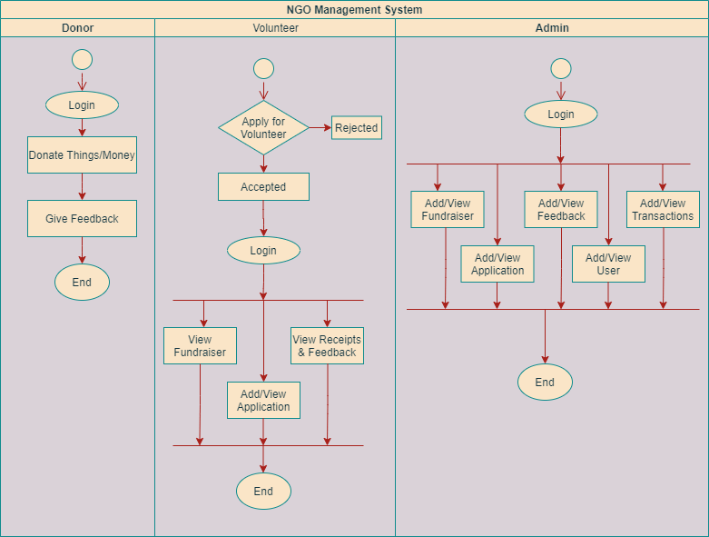

Fig 1: Flow chart

Sequence Diagram for the application

Fig 2: Sequence Diagram

**4.2 Sequence Diagram :**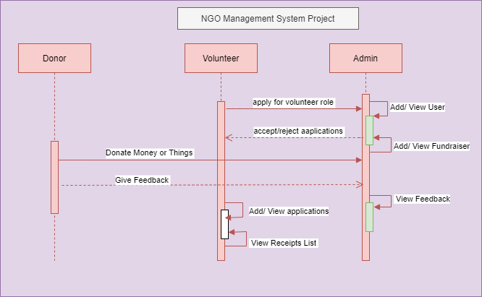

## A sequence diagram is a type of UML (Unified Modeling Language) diagram used to visualize the interactions and communication between objects or components in a software system over time. Sequence diagrams are particularly helpful in depicting the dynamic behavior of a system, showing the order in which interactions occur and the messages exchanged between objects.

**4.3 Data Flow Diagram:**

## A data flow diagram (DFD) maps out the flow of information for any process or system. It gives a basic overview of the whole system or process being analyzed. It shows the system with its relationship to external entities.

## Creating a Data Flow Diagram (DFD) for a donation web application can provide a clear visualization of how data flows through the system and how different components interact with each other

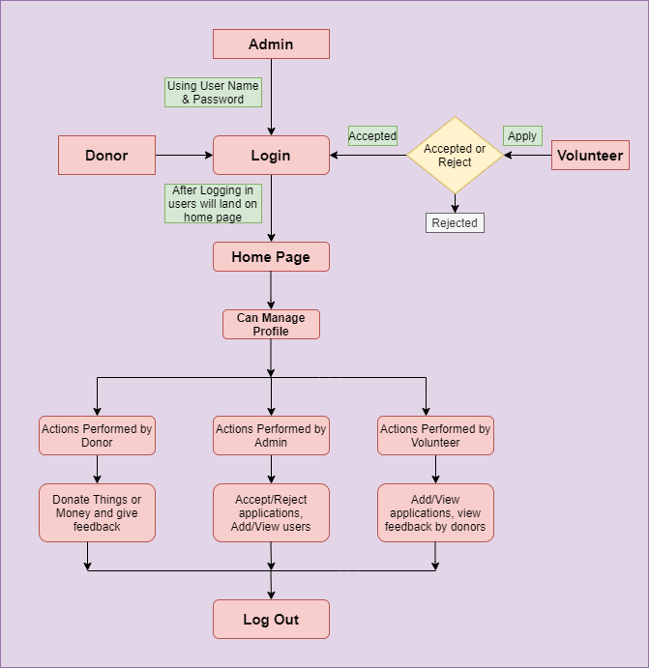

Fig 3: Data Flow Diagram

Fig 4: ER Diagram

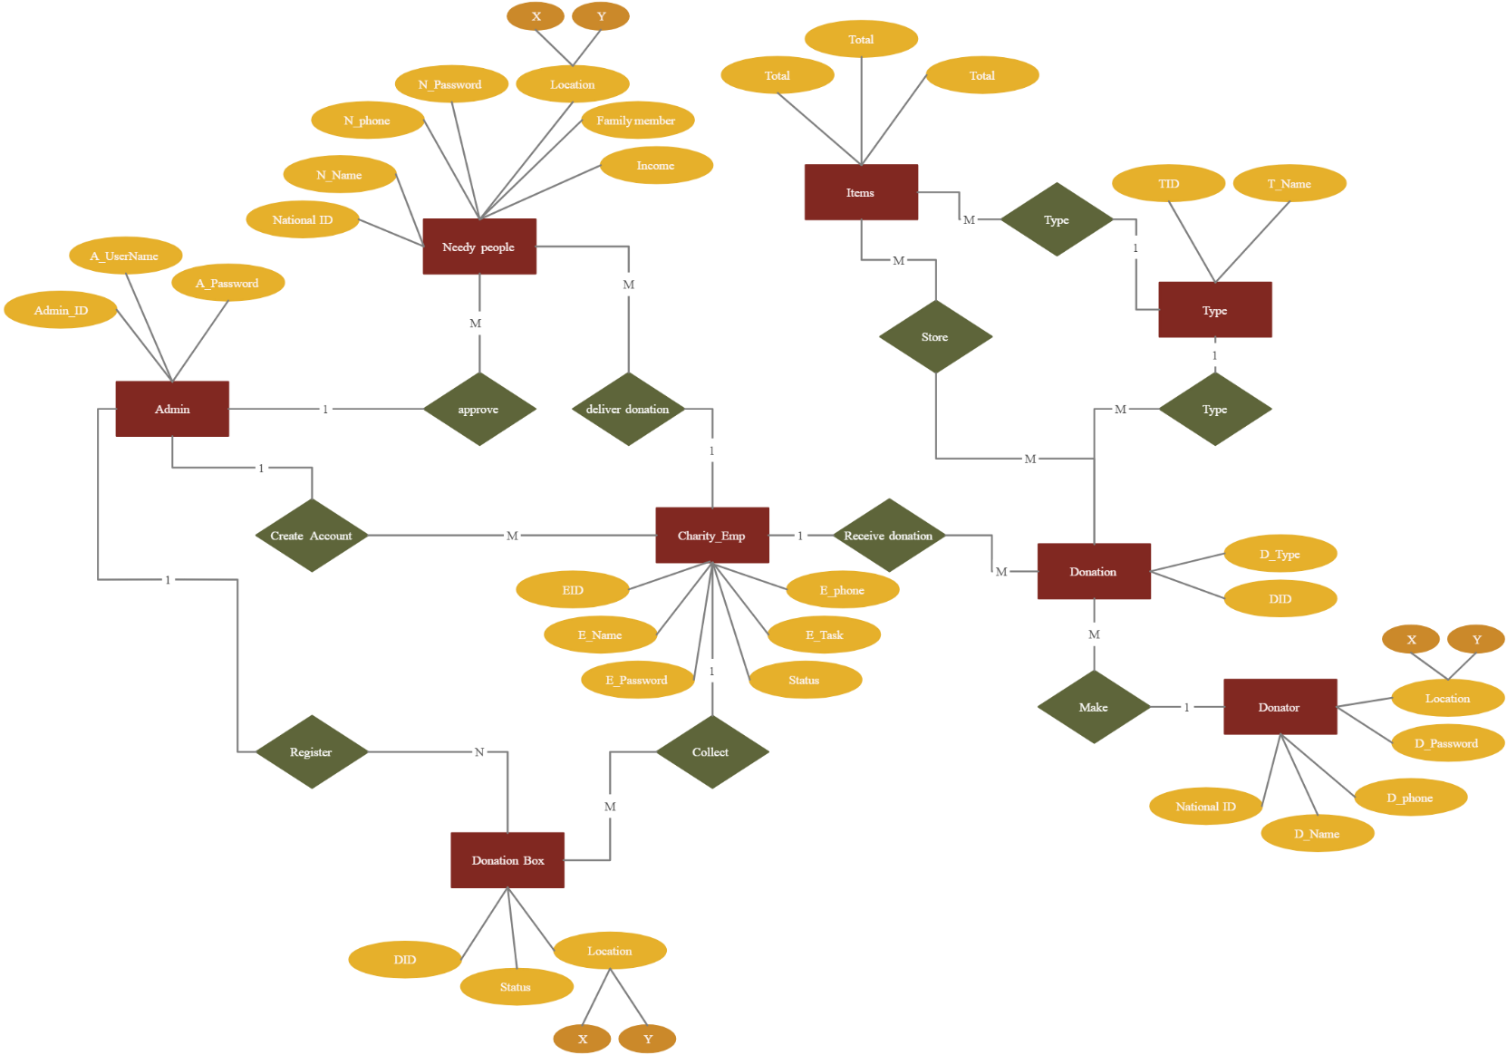**4.4 ER Diagram**

## Creating an Entity-Relationship (ER) diagram for the donor aspect of a donation web application involves identifying the key entities (objects or concepts) and their relationships within the system. Here's an example of an ER diagram for the donor component of a donation web application:

1. Donor Entity (User):

Attributes: DonorID (Primary Key), Name, Email, Phone Number, Address, Donation History.

1. Donation Entity:

Attributes: DonationID (Primary Key), DonorID (Foreign Key), Amount, Donation Type, Date, Status.

1. Donation Type Entity:

Attributes: TypeID (Primary Key), TypeName**.**

**4.5 Test Cases:**

1. Responsive Design Test Cases:
   * Verify that the website layout responds appropriately to different screen sizes, including desktop, tablet, and mobile devices.
   * Check that elements rearrange and resize correctly according to the defined media queries.
   * Test the navigation menu to ensure it remains accessible and usable on smaller screens.
2. Header and Footer Test Cases:
   * Ensure that the header and footer elements (e.g., logo, navigation links, social media icons) are displayed correctly and consistently across all pages.
   * Test the functionality of any interactive elements in the header or footer, such as dropdown menus or contact forms.
3. Content Display Test Cases:
   * Verify that text content is legible and properly formatted across different devices and screen sizes.
   * Check that images load correctly and adjust their size appropriately based on the viewport.
4. Navigation Test Cases:
   * Test all navigation links to ensure they direct users to the correct pages.
   * Check any anchor links within the page to ensure they scroll smoothly to the respective sections.
5. Form Validation Test Cases:
   * If there are any forms on the website (e.g., contact form), test form validation to ensure that required fields are properly validated and error messages are displayed when necessary.
   * Verify that the form submission process works correctly, including sending data to the server and displaying a success message upon successful submission.
6. Interactive Element Test Cases:
   * Test any interactive elements such as image galleries or sliders to ensure they function smoothly and display content properly.
7. Performance Test Cases:
   * Evaluate the website's performance, including page load times and overall responsiveness, to ensure a smooth user experience.
   * Check for any performance bottlenecks, such as large image files or excessive JavaScript/CSS rendering, and optimize as needed.
8. Cross-Browser Compatibility Test Cases:
   * Test the website on different web browsers (e.g., Chrome, Firefox, Safari, Edge) to ensure compatibility and consistent display.
9. Accessibility Test Cases:
   * Evaluate the website's accessibility features, including keyboard navigation, screen reader compatibility, and adherence to accessibility standards (e.g., WCAG).
   * Test with accessibility tools or browser extensions to identify and address any accessibility issues.
10. Security Test Cases:
    * Verify that the website follows best practices for security, such as using HTTPS, sanitizing user input, and protecting against common vulnerabilities (e.g., XSS, CSRF).

**4.6 Methodology**

### Developing a web donation application requires a structured methodology to ensure the project is completed efficiently and effectively. Here's a proposed methodology tailored specifically for building a web donation application:

1. Project Initiation:
   * Define the project scope, objectives, and success criteria.
   * Identify key stakeholders and establish communication channels.
   * Conduct a feasibility study to assess the viability and potential risks of the project.
2. Requirements Gathering:
   * Engage with stakeholders to understand their needs, preferences, and requirements for the donation application.
   * Define functional requirements, such as donation processing, user registration, account management, reporting, and communication features.
   * Identify non-functional requirements, including security, scalability, performance, and usability criteria.
3. Design:
   * Develop a conceptual design for the donation application, including wireframes, mockups, and prototypes.
   * Design the user interface (UI) and user experience (UX) to ensure ease of navigation, accessibility, and engagement.
   * Define the architecture, data model, and technical specifications for the application, considering factors such as scalability, security, and integration with third-party services.
4. Development:
   * Implement the donation application according to the defined requirements and design specifications.
   * Follow best practices for coding, documentation, version control, and testing throughout the development process.
   * Use appropriate technologies and frameworks for web development, such as HTML/CSS, JavaScript, backend programming languages (e.g., Python, Node.js), and database systems (e.g., MySQL, MongoDB).
5. Testing:
   * Conduct thorough testing of the donation application to identify and address any defects, bugs, or usability issues.
   * Perform functional testing to ensure all features and functionalities work as expected.
   * Carry out performance testing to assess the application's responsiveness, reliability, and scalability under various load conditions.
   * Conduct security testing to identify and mitigate potential vulnerabilities, such as SQL injection, cross-site scripting (XSS), and data breaches.
6. Deployment:
   * Prepare the donation application for deployment to a production environment.
   * Configure hosting infrastructure, domain settings, and security measures for the live environment.
   * Deploy the application and perform final checks to ensure it is accessible and functioning properly.
7. Launch and Support:
   * Launch the donation application to users and promote its availability through marketing and communication channels.
   * Provide ongoing support and maintenance for the application, including monitoring, troubleshooting, and updates.
   * Gather feedback from users and stakeholders to identify areas for improvement and prioritize future enhancements.
8. Evaluation and Iteration:
   * Continuously monitor and evaluate the performance, usability, and impact of the donation application.
   * Collect metrics and analytics data to measure key performance indicators (KPIs), such as donation volume, user engagement, and conversion rates.
   * Use feedback and insights to iterate on the application, making improvements and enhancements to meet evolving needs and preferences.

**CHAPTER 5 – TESTING MODULE**

## For a donation website, implementing a robust testing strategy is crucial to ensure the platform's reliability, security, and user experience. The testing module encompasses several types of tests, each designed to evaluate different aspects of the website. Here's an overview of the types of testing that are commonly used for a donation website:

1. Functional Testing

* Purpose:To verify that all features of the website work as intended. This includes testing the donation process, user registration and login, form submissions, and any interactive elements.
* Methods:Manual testing, automated testing using tools like Selenium or Cypress, unit testing for individual functions.

1. Security Testing

* Purpose:To ensure that the website is secure from external threats and protects user data effectively. This is critical for a donation website handling sensitive financial information.
* Methods:Penetration testing, vulnerability scanning using tools like OWASP ZAP or Nessus, and testing for compliance with security standards (PCI DSS for payment processing, GDPR for data protection).

1. Performance Testing

* Purpose:To ensure that the website can handle high traffic volumes and perform well under load. This is important for maintaining a good user experience during peak donation periods.
* Methods:Load testing, stress testing, and using tools like JMeter or LoadRunner to simulate multiple users accessing the website simultaneously.

1. Usability Testing

* Purpose**:** To evaluate the website's ease of use and the overall user experience. This helps identify any navigation issues or barriers that might prevent users from completing donations.
* Methods**:** User testing sessions, A/B testing for different design elements, and heuristic evaluations to assess usability.

1. Compatibility Testing

* Purpose:To ensure the website works correctly across different devices, browsers, and operating systems. This is crucial for reaching a broad audience.
* Methods:Testing on multiple browsers (Chrome, Firefox, Safari, etc.), devices (smartphones, tablets, desktops), and operating systems (Windows, macOS, iOS, Android).

1. Regression Testing

* Purpose:To verify that new updates or features haven't broken existing functionality. This is important for maintaining the integrity of the website over time.
* Methods:Automated testing to run existing test cases against modified software, ensuring no new bugs have been introduced.

# CHAPTER 6 – PERFORMANCE OF THE PROJECT DEVELOPED

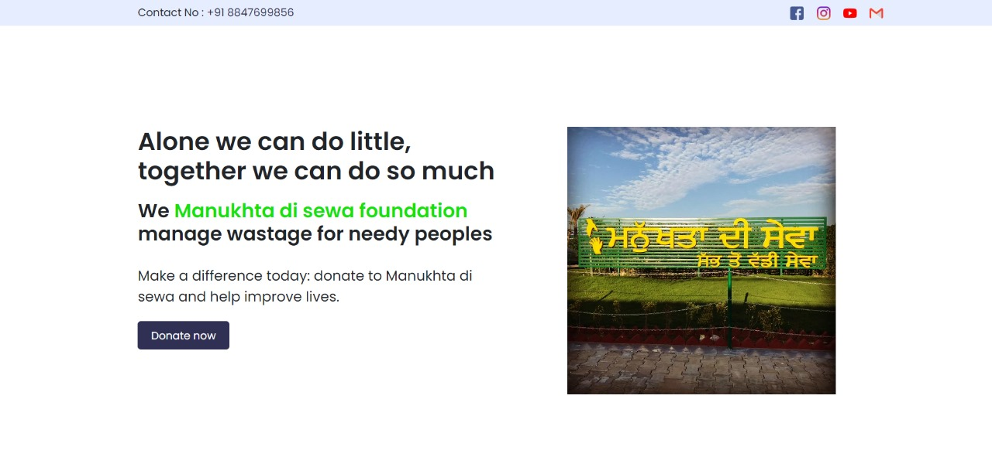Fig 4: Home page

The homepage of a donation web application serves as the first point of contact for users, offering them a glimpse into what the platform is about and enticing them to explore further or take action. Here's an explanation of key elements typically found on the homepage of a donation web application:

1. **Header**: The header section typically includes the logo of the application, navigation menu, and possibly a call-to-action button for signing up or logging in. It provides users with easy access to different sections of the website.
2. **Hero Section**: This is the prominent, attention-grabbing section at the top of the homepage. It often contains a powerful image or video related to the cause the application supports, along with a brief tagline or message that communicates the mission and impact of the platform.
3. **About Us**: A brief introduction to the organization behind the donation platform, including its mission, values, and goals. This section may also include information about any partnerships or affiliations.
4. **Featured Campaigns/Projects**: Highlighting current or ongoing campaigns or projects that users can donate to. These could be displayed as thumbnails with images, titles, short descriptions, and progress bars indicating fundraising goals.
5. **How It Works**: An overview of the donation process, outlining the steps users need to take to make a contribution. This section helps users understand the platform's functionality and builds trust by transparently explaining how their donations will be used.
6. **Testimonials**: Positive feedback from donors, beneficiaries, or partners can be showcased to build credibility and trust. Testimonials can include quotes, photos, or videos that highlight the impact of donations facilitated through the platform.
7. **Call-to-Action (CTA)**: A clear and prominent button or link prompting users to take action, such as donating now, signing up for updates, or exploring featured campaigns. The CTA should be visually distinct and strategically placed to encourage user engagement.
8. **Social Proof**: Displaying metrics such as the total amount of donations raised, number of donors, or successful projects completed can help establish credibility and encourage participation.
9. **Footer**: The footer typically contains additional navigation links, contact information, social media icons, and legal disclaimers. It provides users with supplementary information and resources while also reinforcing the credibility of the platform.

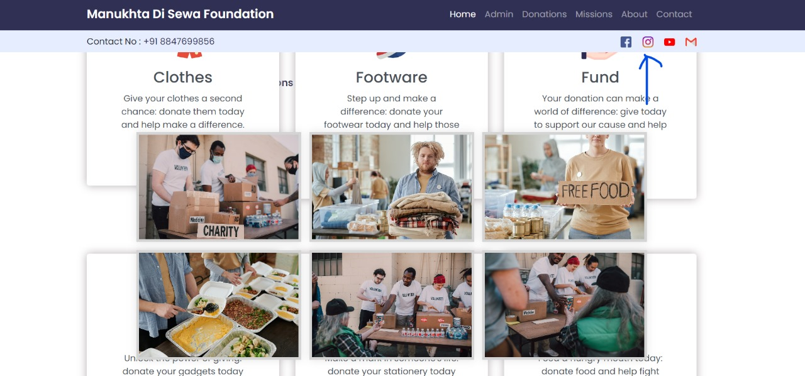

Fig 5: Selection of the type of donation

## The donation selection page within a web application is a crucial step in the donation process, providing donors with options to tailor their contributions according to their preferences and interests. This page typically offers various types of donations that align with the organization's mission and the donor's philanthropic goals.

## Upon reaching this page, donors are presented with a range of donation categories or causes to choose from, such as education, healthcare, disaster relief, environmental conservation, or community development. Each category may be accompanied by a brief description highlighting the impact of donations in that particular area.

## Additionally, donors may have the option to select specific projects or campaigns within each category, allowing them to support initiatives that resonate with them personally. For example, within the education category, donors might choose to support scholarships, school infrastructure, or educational programs.

## Furthermore, the donation selection page may provide donors with flexibility in choosing the donation amount, frequency (one-time or recurring), and any additional options such as dedicating the donation in honor of someone or contributing anonymously.

Overall, the donation selection page aims to empower donors by offering them choices and customization options, thereby enhancing their engagement and satisfaction with the donation experience. It serves as a pivotal bridge between donors' intentions and the tangible impact their contributions can make in the world

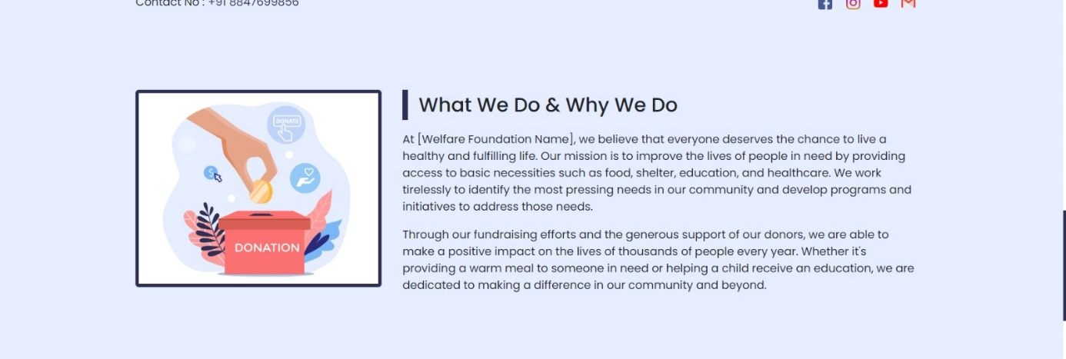Fig 6: About us (the NGO)

Manukhta Di Sewa (MDS) is a non-governmental organization (NGO) dedicated to serving humanity with a focus on providing aid and support to those in need. The name "Manukhta Di Sewa" translates to "Service to Humanity" in Punjabi, reflecting the organization's core mission of selflessly serving others. Founded on the principles of compassion, empathy, and social responsibility, Manukhta Di Sewa operates with the belief that every individual deserves dignity, respect, and access to basic necessities. The organization works tirelessly to alleviate the suffering of marginalized communities, including the homeless, impoverished, and underserved populations. Manukhta Di Sewa's initiatives span a wide range of areas, including:

1. **Food Distribution**: MDS organizes regular food distribution drives to provide nutritious meals to the homeless and hungry. These efforts ensure that individuals facing food insecurity have access to sustenance and support.
2. **Clothing Drives**: Recognizing the importance of adequate clothing for dignity and comfort, MDS conducts clothing drives to collect and distribute clothing items to those in need, especially during harsh weather conditions.
3. **Education and Skill Development**: MDS is committed to empowering individuals through education and skill development programs. By offering educational resources, vocational training, and mentorship opportunities, the organization aims to uplift individuals and equip them with the tools for self-sufficiency.
4. **Medical Aid and Healthcare Services**: MDS facilitates access to medical care and essential healthcare services for disadvantaged communities. This includes organizing medical camps, providing medical supplies, and covering treatment expenses for individuals who cannot afford healthcare.
5. **Disaster Relief**: In times of natural disasters or humanitarian crises, MDS mobilizes relief efforts to provide immediate assistance to affected communities. This includes distributing emergency supplies, providing shelter, and offering support for recovery and rebuilding efforts.
6. **Advocacy and Awareness**: Beyond direct assistance, MDS engages in advocacy efforts to raise awareness about social issues affecting vulnerable populations. By advocating for policy changes and promoting social justice initiatives, the organization strives to address root causes of inequality and injustice.

Through its unwavering commitment to service and compassion, Manukhta Di Sewa exemplifies the transformative power of grassroots activism and community-driven initiatives. By fostering a culture of empathy and solidarity, the organization inspires individuals to come together and make a meaningful difference in the lives of others, embodying the spirit of "sewa" (selfless service) in action

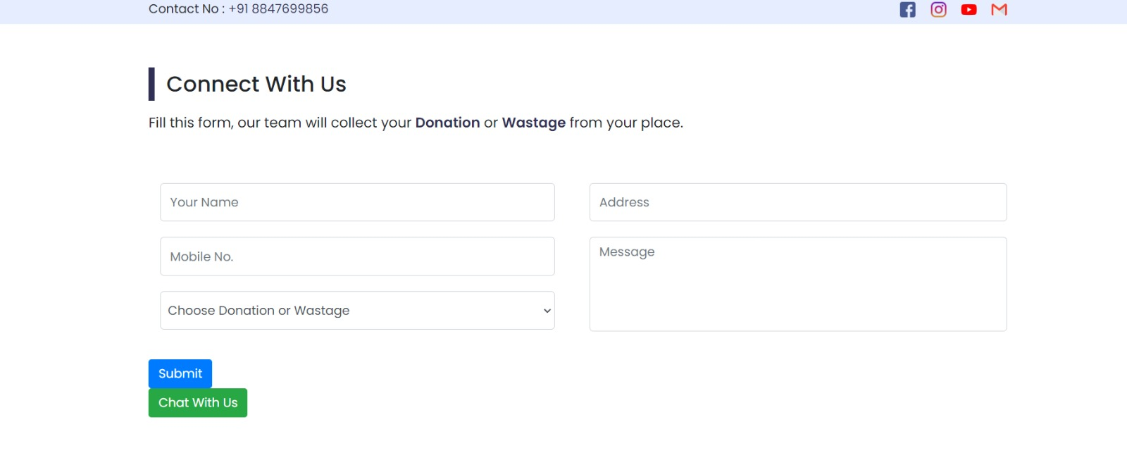

Fig 7: Contact information

Managing donor contact information in a donation web application is a crucial aspect of maintaining transparency, building trust, and facilitating effective communication. Here's a piece about the significance and best practices regarding donor contact information.Ensuring Transparency and Trust: Managing Donor Contact Information

In the realm of online donations, transparency and trust are paramount. Donors need assurance that their contributions are making a real difference and that their personal information is handled with care. Managing donor contact information in a donation web application plays a pivotal role in fostering this trust while facilitating seamless communication between the organization and its supporters.

First and foremost, collecting donor contact information allows organizations to express gratitude and provide acknowledgment for contributions. A simple 'thank you' can go a long way in reinforcing a donor's connection to the cause and encouraging future support. Additionally, having accurate contact details enables organizations to issue tax receipts, which are often essential for donors seeking tax deductions on their contributions.

Furthermore, donor contact information serves as a means for organizations to keep supporters informed about their impact. Whether through newsletters, email updates, or social media posts, organizations can share success stories, project milestones, and upcoming initiatives, keeping donors engaged and involved in the cause they care about.

## However, it's essential to handle donor contact information with the utmost respect for privacy and security. Organizations must adhere to data protection regulations and implement robust security measures to safeguard donor data from unauthorized access or misuse. Providing clear information about how donor data will be used and offering opt-in/opt-out mechanisms for communication preferences empower donors to control their engagement with the organization.

## Moreover, maintaining accurate and up-to-date donor contact information is essential for effective fundraising efforts. Regularly updating donor records ensures that communications reach the intended recipients and allows organizations to tailor their outreach strategies based on donor preferences and interests.

Fig 8: Admin Login

## In conclusion, donor contact information is not just a collection of data points; it's a vital link between organizations and their supporters. By managing this information transparently, respectfully, and securely, organizations can cultivate trust, foster engagement, and ultimately drive meaningful impact in pursuit of their mission.

## The donor's admin login page in a donation web application serves as a secure gateway for authorized users to access their accounts and manage their donation-related activities. Here's an overview of the key features and functionalities typically found on the donor's admin login page:

1. **Username and Password Fields**: The login page prompts users to enter their username or email address and password to authenticate their identity. This helps ensure that only registered donors with valid credentials can access their accounts.
2. **Security Measures**: To protect user data and prevent unauthorized access, the login page may incorporate security measures such as captcha verification, two-factor authentication (2FA), or account lockout mechanisms after multiple failed login attempts.
3. **Access Permissions**: Depending on the donor's role and privileges, the login page may grant access to different features and functionalities within the admin dashboard. For example, regular donors may have access to view their donation history and update their personal information, while administrators or super-users may have additional permissions to manage campaigns, view analytics, and generate reports.

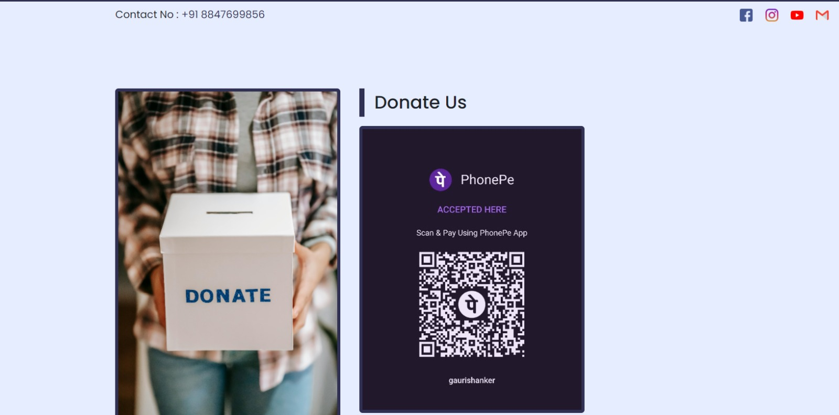

Fig 9: Payement Method

Integrating QR code payment methods into a web donation application adds a convenient and efficient way for users to make contributions. Here's how the QR code payment method can be implemented and its benefits:

1. **Generation of QR Codes**:
   * The donation application generates unique QR codes for each donation transaction. These QR codes encode information such as the donation amount, recipient details, and transaction identifier.
   * The QR codes can be dynamically generated based on user input, allowing donors to specify the donation amount and any additional information before generating the QR code.
2. **Displaying QR Codes**:
   * Once generated, the QR codes are displayed on the donation platform's interface, typically on the donation confirmation page or during the checkout process.
   * Donors can scan these QR codes using their mobile devices' camera or a dedicated QR code scanner app.
3. **Scanning and Processing QR Codes**:
   * Donors scan the QR codes using their smartphones or other compatible devices.
   * The scanning device decodes the information embedded in the QR code and initiates the payment process.
   * The donor's payment app or mobile banking app opens automatically, pre-populated with the donation amount and recipient details.
4. **Payment Authorization**:
   * The donor reviews the transaction details within their payment app and authorizes the payment using their preferred payment method, such as credit/debit card, mobile wallet, or online banking.
   * Once the payment is authorized, the donation amount is transferred from the donor's account to the recipient's account.
5. **Real-time Confirmation**:
   * The web donation application receives real-time confirmation of the payment from the payment gateway or financial institution.
   * The donation status is updated immediately, and the donor is notified of the successful transaction.

Benefits of QR Code Payment Method in Web Donation Applications:

1. **Convenience**: QR code payments offer a seamless and hassle-free donation experience for users. Donors can quickly scan the QR code and complete the transaction within seconds, without the need to manually enter payment details.
2. **Accessibility**: QR code payments are accessible to users with smartphones or devices equipped with a camera and QR code scanning capability. This widens the reach of the donation application to a broader audience.
3. **Security**: QR code payments leverage secure encryption protocols and tokenization to protect sensitive payment information during transmission. Donors can trust that their payment details are safe and secure when making donations through QR codes.
4. **Instant Gratification**: Donors receive immediate confirmation of their donation after scanning the QR code and completing the payment process. This instant gratification reinforces trust and encourages continued engagement with the donation platform.
5. **Cost-Effectiveness**: QR code payments typically incur lower processing fees compared to traditional payment methods, making them a cost-effective option for donation processing. Charitable organizations can maximize the impact of donations by minimizing transaction fees.

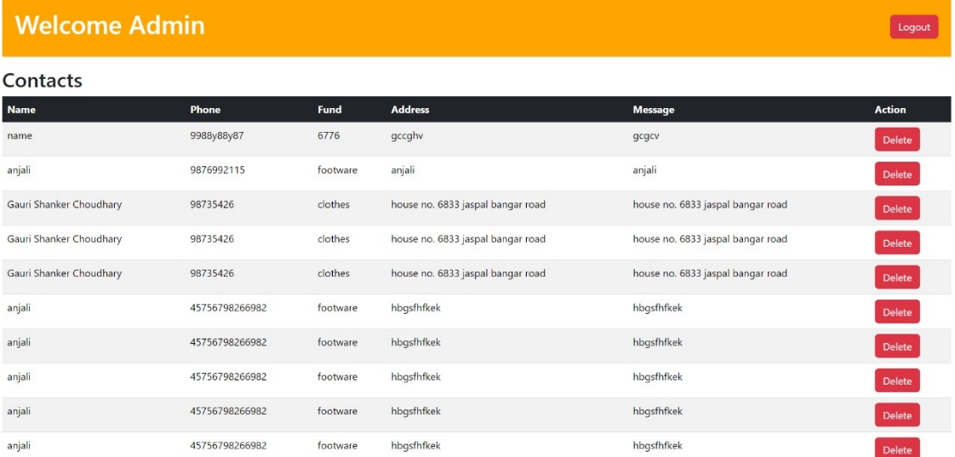

Fig 10: Database

The MySQL screenshot for a donor in a donation web application provides a behind-the-scenes glimpse into the database architecture and functionality that powers the platform's donation management system. This screenshot typically showcases various tables and fields within the database that store crucial information related to donor transactions, user profiles, donation history, and other relevant data.

1. Key components of the MySQL screenshot may include:

Donor Information: This section of the database contains details about individual donors, such as their name, contact information, account credentials (if applicable), and any additional demographic or personal information provided during registration.

1. Transaction Records: The transaction table records each donation made by a donor, including the donation amount, date and time of the transaction, payment method used, and any associated notes or comments provided by the donor.
2. Donation Categories/Projects: This part of the database lists the different categories or projects available for donation within the web application. Each category or project is assigned a unique identifier and may include attributes such as a title, description, fundraising goal, and current donation status.
3. User Authentication and Authorization: The database may contain tables related to user authentication and authorization, storing encrypted passwords, access permissions, and session tokens to ensure secure access to the donation platform.
4. Relationships and Associations: Tables within the database may establish relationships and associations between donors, donations, campaigns, and other entities. For example, a donor may be linked to multiple donations, and each donation may be associated with a specific campaign or project.
5. Data Integrity Constraints and Indexes: The database may include constraints and indexes to enforce data integrity rules, ensure consistency, and optimize query performance. Constraints such as primary keys, foreign keys, and unique constraints help maintain referential integrity and prevent data anomalies.



Fig 11: Sidebar

Here, in this sidebar one can find the social media handle links like on Youtube, Facebook, Instagram, and Gmail. And following are the tabs that would be shown.

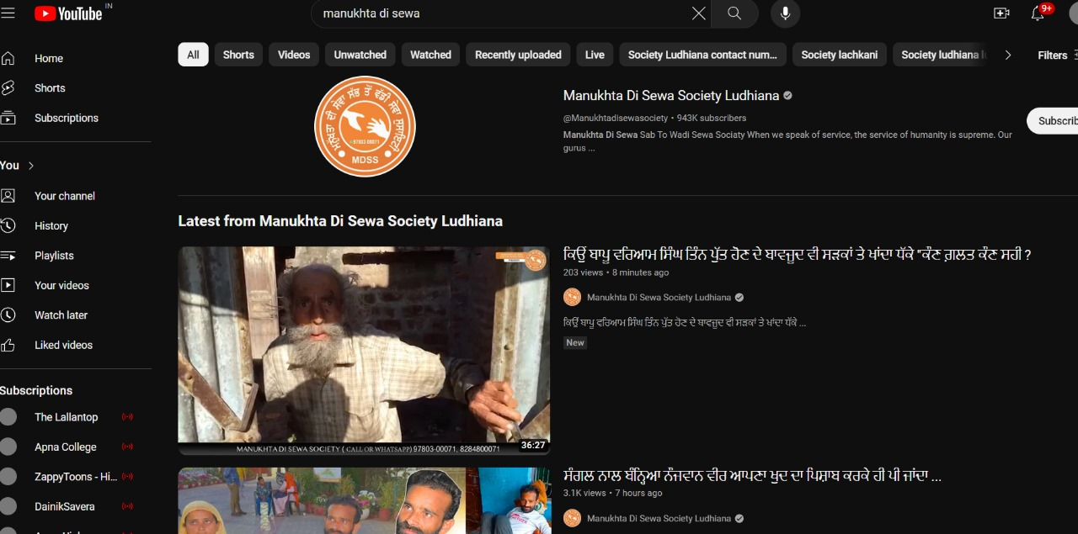

Fig 12: Youtube handle of Manukhta Di Sewa society

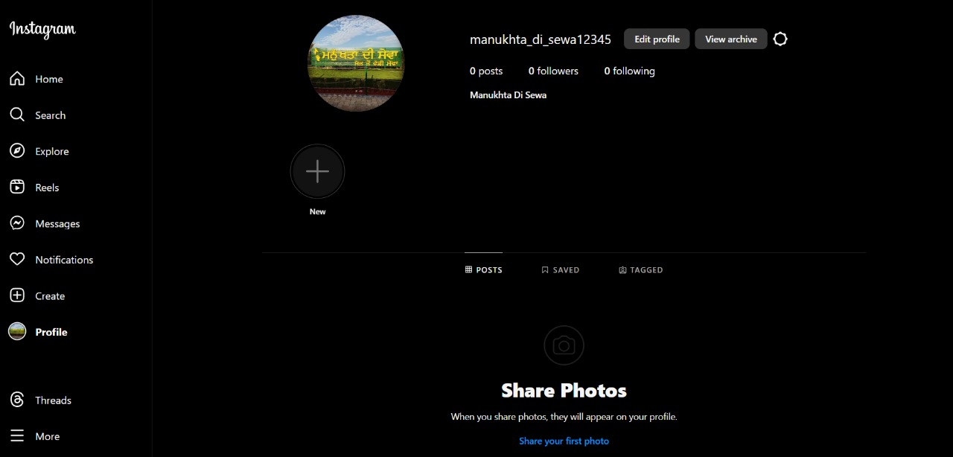Fig 13: Instagram handle

**Chapter 7 – Future Scope**

* 1. **Future Scope**

Expanding the scope of our web donation application can lead to significant enhancements and new opportunities. Here are some future scope ideas:

1. Integration with Social Media Platforms:

Allow users to share their donation activities on social media platforms like Facebook, Twitter, and Instagram. This could increase visibility and encourage others to contribute to the cause. Implementing social media integration can also facilitate viral campaigns and fundraising challenges.

1. Mobile Application Development:

Extend the reach of the donation platform by developing native mobile applications for iOS and Android devices. Mobile apps can offer a more seamless and convenient donation experience, allowing users to contribute on-the-go. Implement features like push notifications to keep users updated on donation campaigns and progress.

1. Enhanced User Profiles:

Develop comprehensive user profiles where donors can track their donation history, view their impact on different causes, and receive personalized recommendations for future contributions. Implement features such as badges or recognition levels based on donation milestones to gamify the donation experience and foster user engagement.

1. Blockchain Technology Integration:

Explore integrating blockchain technology to enhance transparency, security, and trust in the donation process. Implementing blockchain-based donation tracking can provide donors with immutable records of their contributions, ensuring that donations are used as intended and reducing the risk of fraud or mismanagement.

1. Machine Learning for Personalized Recommendations:

Utilize machine learning algorithms to analyze donor behavior, preferences, and past donation patterns. Leverage this data to provide personalized donation recommendations tailored to each user's interests and philanthropic goals. Implement features like donation suggestion algorithms based on user demographics, browsing history, and donation history.

1. Real-time Impact Visualization:

Implement interactive data visualization tools to showcase the real-time impact of donations. Use charts, graphs, and maps to illustrate how donations are being utilized, the progress of ongoing projects, and the outcomes achieved. Provide donors with visual feedback on the tangible difference their contributions are making in the world.

1. Global Expansion and Multilingual Support:

Expand the reach of the donation platform by providing support for multiple languages and currencies, enabling users from diverse backgrounds to participate. Implement localization features to tailor the user experience based on the user's geographic location, cultural preferences, and language preferences.

1. Peer-to-Peer Fundraising Capabilities:

Enable users to create their own fundraising campaigns and solicit donations from their social networks. Implement peer-to-peer fundraising features where users can set fundraising goals, share their stories, and track the progress of their campaigns. Provide tools for campaign organizers to engage with donors, thank supporters, and rally their community around a common cause.

## CHAPTER 8 – REFERENCES

## https://nevonprojects.com/wp-content/uploads/2021/05/nevon-waste-food-

## management-app-wt.jpg

## https://www.figma.com/community/file/1095643048965426874/cloth-donation-app

## <https://www.donatekart.com/>